“YOU Can Get $100’s In Your Mailbox Almost EVERYDAY Like We’ve Been Doing for the Past 22 MONTHS!”

**Our Unique Method of Getting CASH Works EVERY TIME WE USE IT... and... This Is YOUR INVITATION To Join Us!!!**

**It Only Takes FIVE (5) Minutes to REQUEST YOUR FREE STARTER KIT!**

YOUR FREE Starter Kit includes:

* **ALL THE ANSWERS to Your Questions.**
* **Everything You Need To Do What We Do!**
* **Straight Forward Path To Extreme Cash!**

**This is An Easy, Cheap, Simple, PROVEN**, **and Automated** Cash Getting System. ***We’ve NEVER Missed A Payment, and we’re still going STRONG!!!!***

***Don’t Believe Me?***

Call and Listen to Just a Few Success Stories:

**1-888-997-4928**

***Toll Free - 24/7 Recorded Line - Pick a Real Life Testimonial & Listen!***



GO TO

**www.MyFreeCashKit.com**

**ACCESS CODE: {enter your kit ID here }**

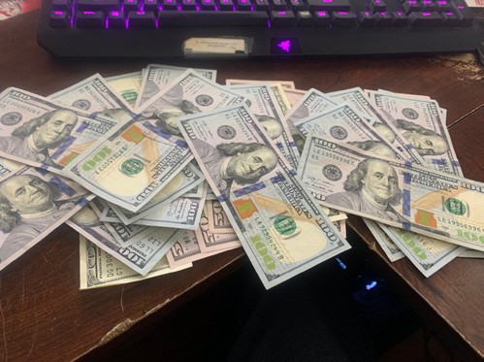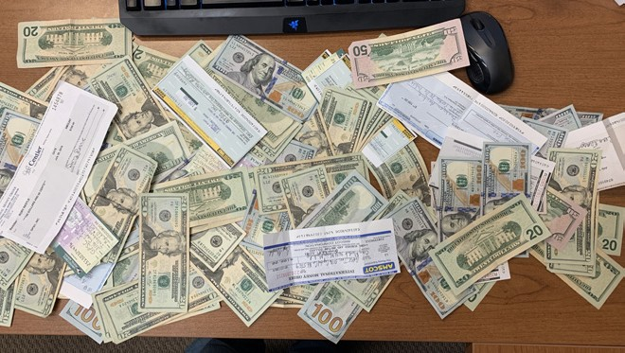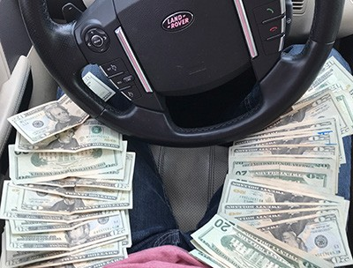

**Will you be our next Success Story?**

No Internet or Computer? No Problem... Simply send this flyer back to me **with your name and address**, and I'll get your Free Starter Kit out to you ASAP!  
  
GPSC, INC  
3116 Capital Circle NE STE 9  
Tallahassee, FL 32308

Cash in Your Mailbox on a Regular Basis?

Turn Over for More Information!

www.MyFreeCashKit.Com

Enter Your Access Code: **{enter your kit ID here }**